Jinan Quanhua Packing Product CO.,LTD.
INTRODUCTION
- Company Profile
- Product
- Service
- Strategic Planning
一、Company Profile

Jinan Quanhua Packing Products Co., Ltd was founded in 2000, It is a favorable place to produce green products with good location and convenient traffic. Our company covers 80,000 square meters with the total capital of RMB 300 million.
We are specialized in designing, making and marketing various products, including paper, aluminum composite packaging paper (gable-top cartons).
Our company can produce more than 1.5 billion various gable-top cartons every year.
Intelligent packaging clean plant, annual capacity will be 3 billion in future
Our new factory in HeNan can produce scale of 10 billion packs of AL-PE-PA aseptic package materials every year.

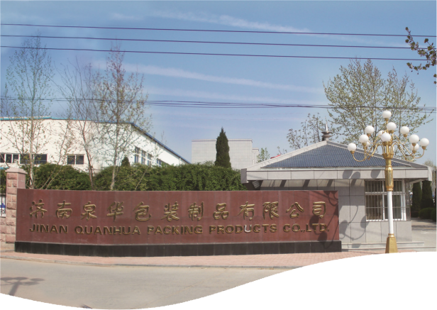
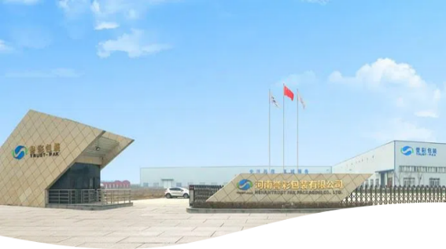
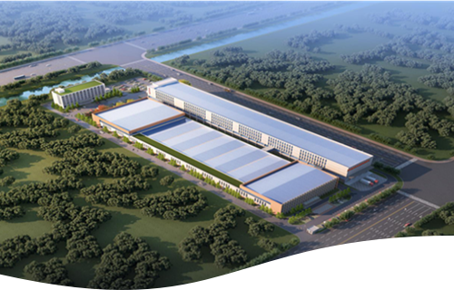
Qualifications and Honor：
（1）has a municipal research and development center, more than 10 patents
（2）Top Ten Packaging and Printing Enterprises in Shandong Province
（3）Shandong Light Industry System Star Enterprise
（4）Shandong Province Quality Management Advanced Enterprise
（5）Jinan Green Factory
（6）Jinan City Specialized and Special New Enterprise
（7）"Quanhua" brand Gable Top Pack won the "Jinan first batch of
（8）advantageous industrial products", "Shandong well-known brands",
（9）"Shandong packaging and printing gold award products",
（10）"China printing award bronze award, excellence award" and other awards
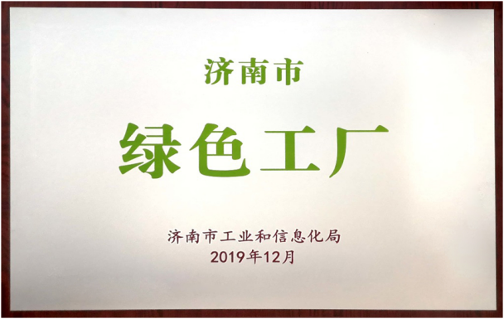
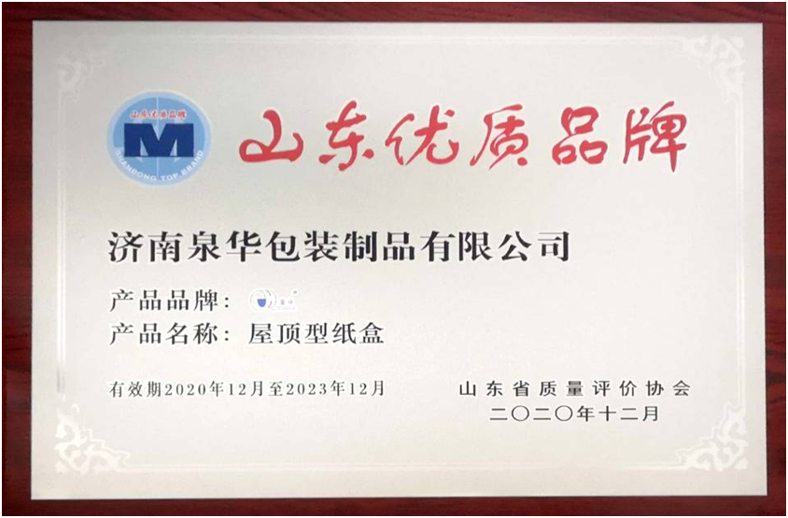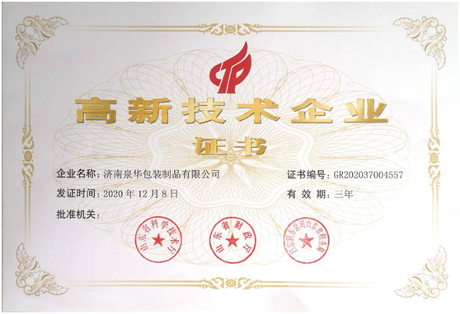
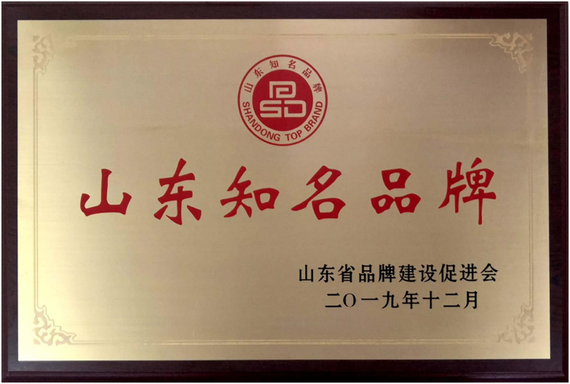
Certificate：
Certificate of Food Safety Management System GB/T 19001-2006/ISO 9001:2015
Certificate of Environmental Management System GB/T 24001-2016/ISO 14001:2015
Food Safety System Certification
FSSC 22000
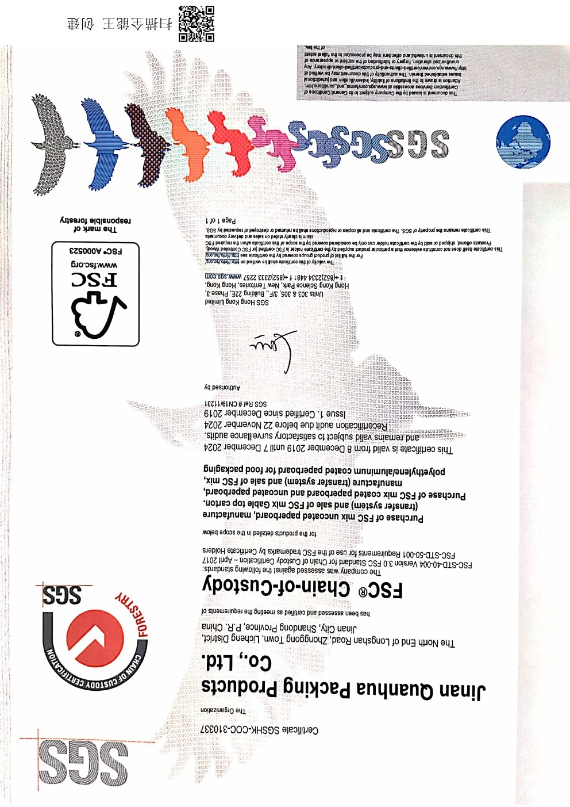
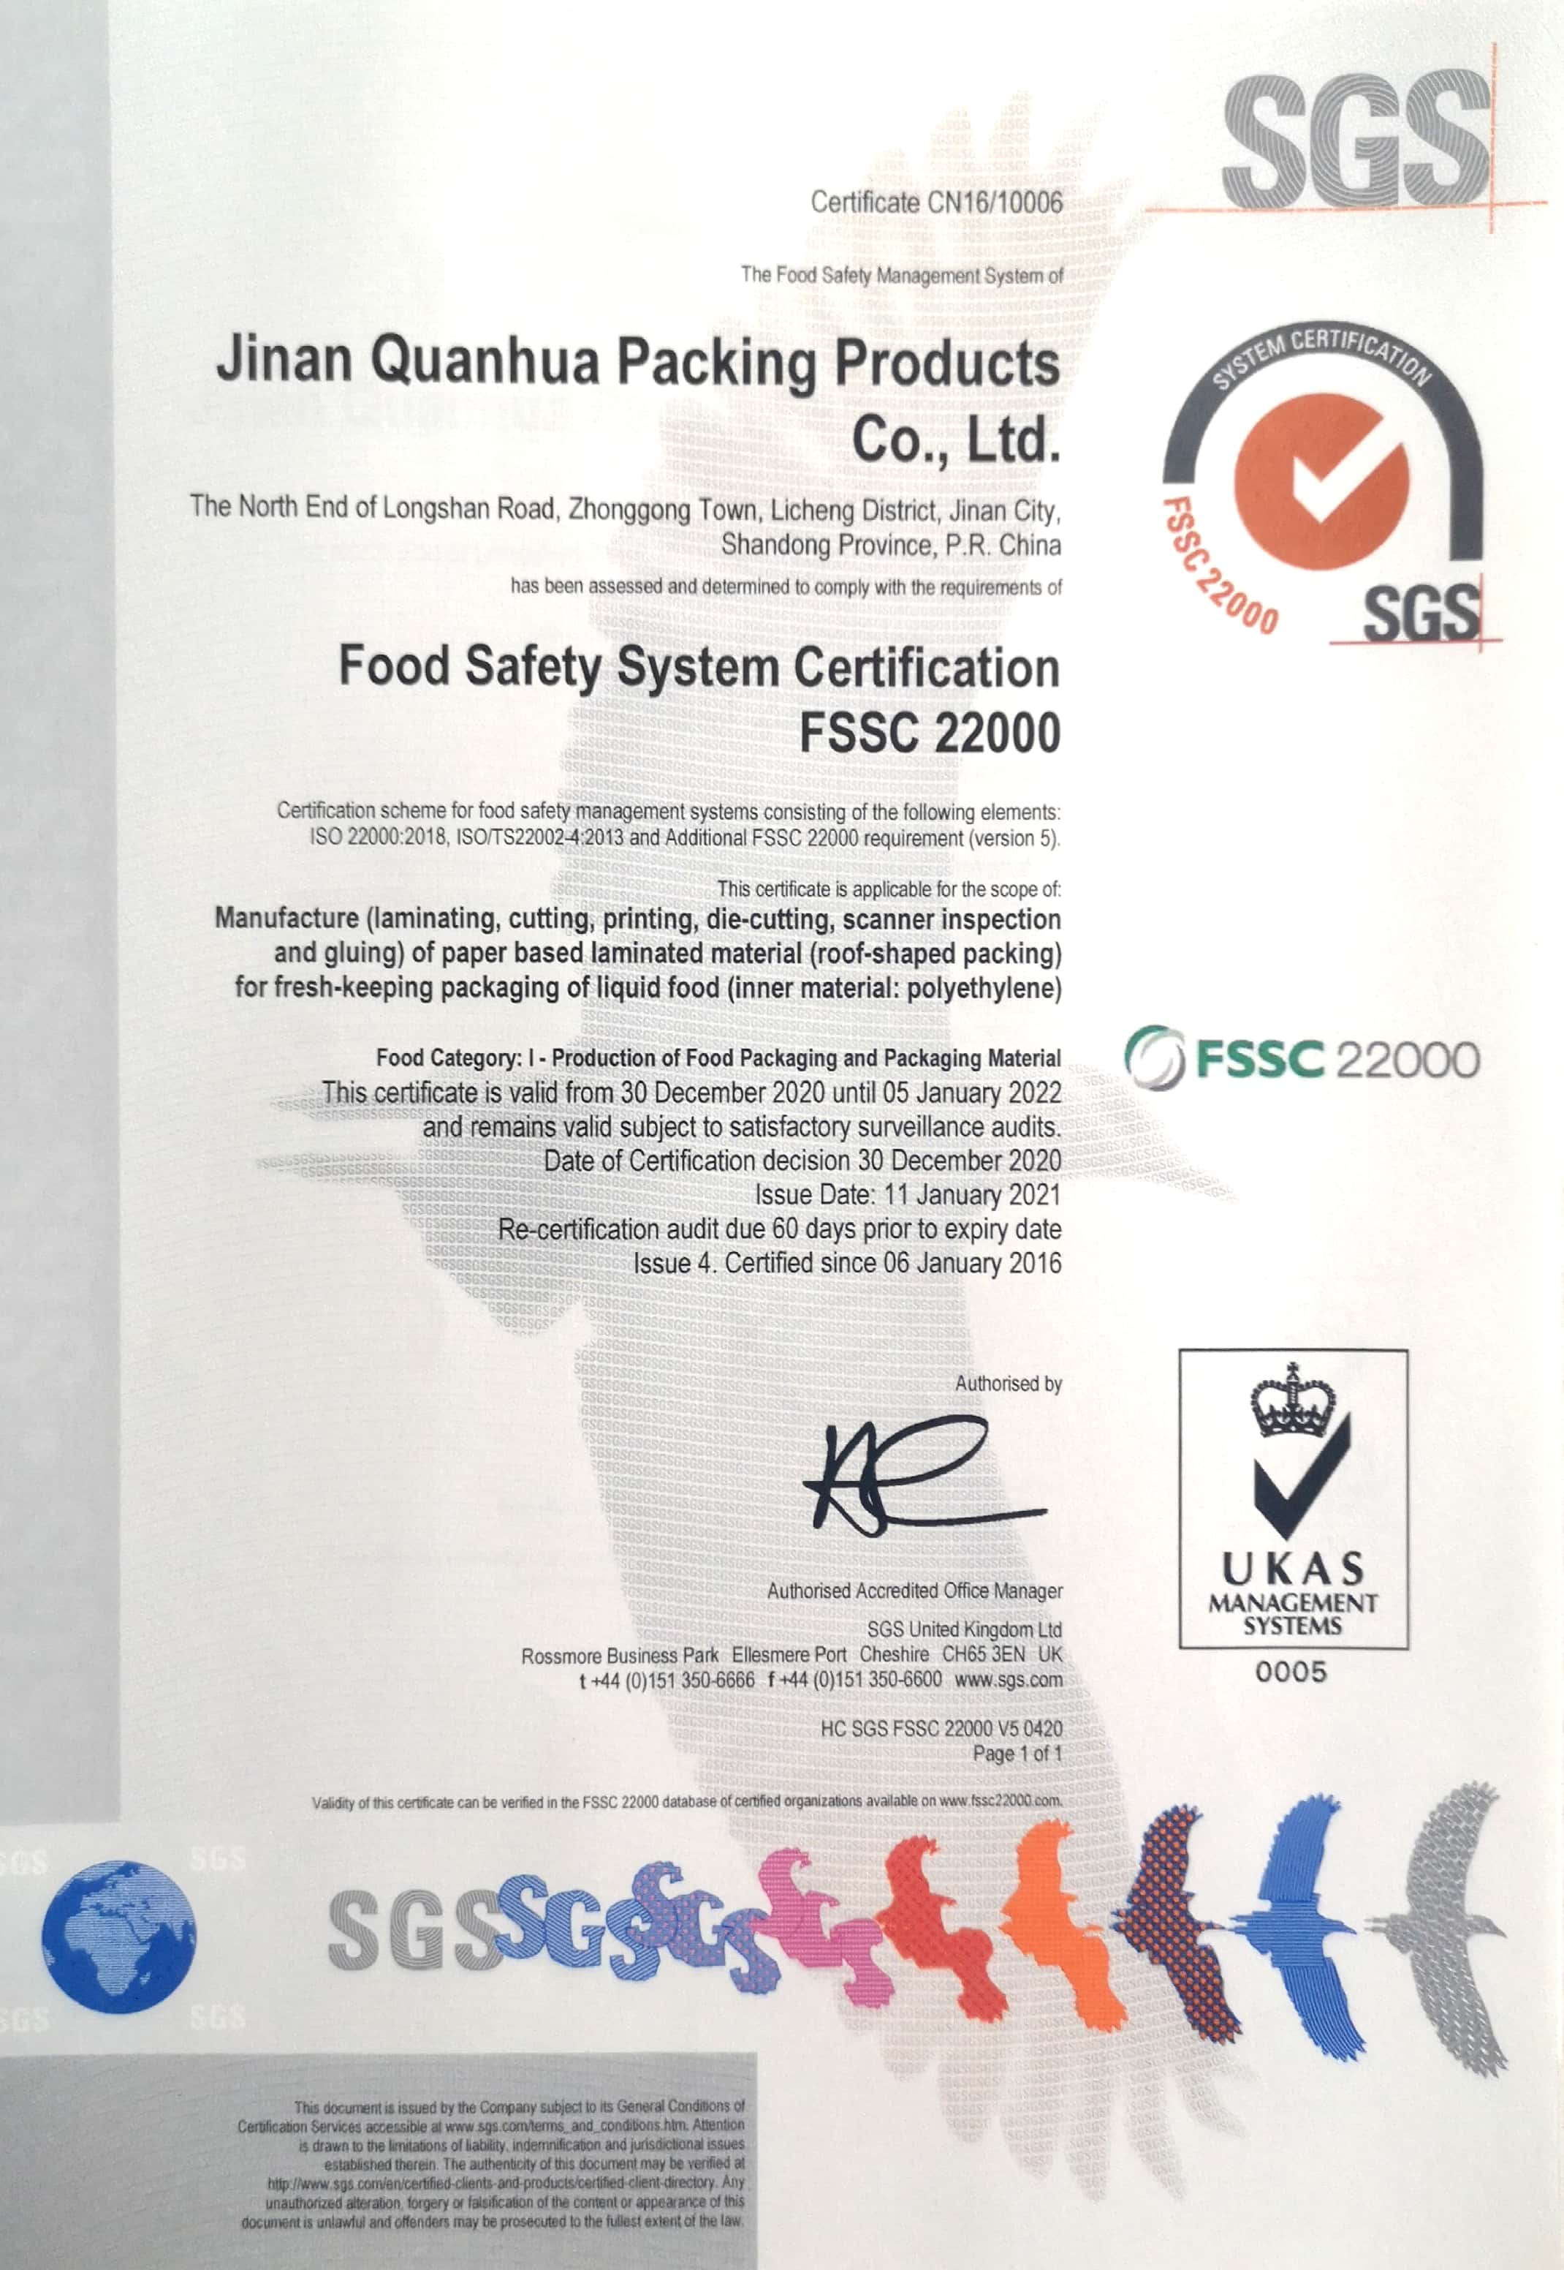
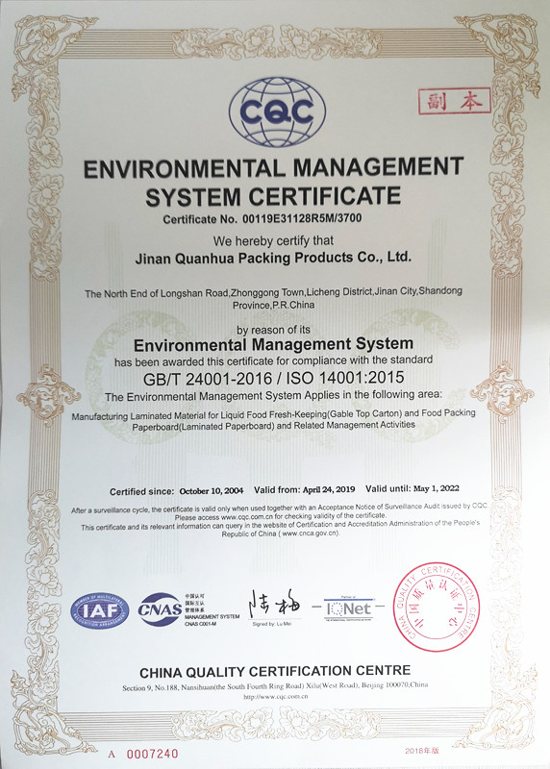
FSC
二、Product
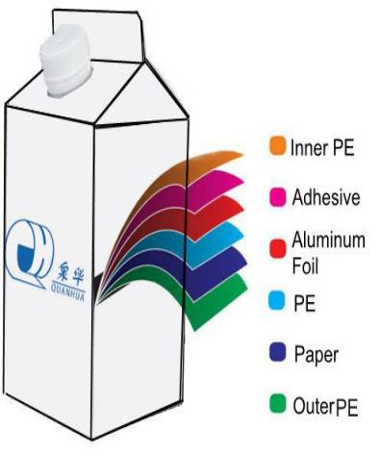
Normal Temperature Gable Top Pack（A、B、C Type）
（1）6layer laminated material;
（2）used for milk, juice, coffee, water,
（3）red wine ..
（4）liquid food package;
（5）Normal temperature storage;
（6）shelf life 6-12moths

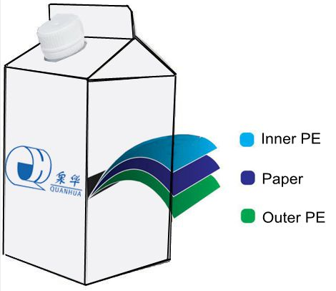
Fresh Gable Top Pack （ A、B Type）
（1）3layer laminated material;
（2）used for pasturized milk, youghurt, cream .. food package
（3）0-4℃ temperature storage;
（4）shelf life 7-21days

三、SERVICE
We provide complete solutions to our customers, thanks to our close relationship with our partners: filling machines producers, ancillary material suppliers and communication agencies.
Our technical team works together with our customers to implement the most efficient and reliable solution, but also to quickly fix any issue in order to minimize disruption. Our qualified engineers focus on:
Fine tune customer,s packaging equipment .
Identify and recommend optimized solutions for packaging handling.
Mechanical preventive maintenance on filling machines as full service.
Our design department is separate unit working closely with production.
The services provided range from the total development of an image of the product to the simple adaptation of artworks delivered by the customer
We offer 24/7 technical services, spares and support, as well as filling machine audits, maintenance contracts and training of customer staff such as operators and technicians.
四、Strategic planning

To be the best Gable Top Carton packaging manufacturer in China, lead the development of the industry, and provide complete paper packaging technology,include paper selection, design, printing, filling.
Provides a platform for each employee to realize their own value, and creates a sophisticated and efficient team for the enterprise
Strengthen the export of foreign trade, layout the international roof box packaging market, and become an influential food packaging enterprise in the world.
Introduce market capital through IPO. Production plant layout of the country, do the largest domestic roof box supplier.

